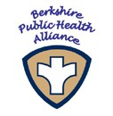

Berkshire Public Health Alliance
1 Fenn Street Suite 201, Pittsfield, Massachusetts 01201

Alliance Mini Grant Subcommittee Meeting

April 10th, 2023
12:00 p.m.
1 Fenn St, Pittsfield, Suite 201

AGENDA

- MiniGrant requests:

  - Egremont
  - Peru
  - Dalton (if received in time)

- Unforeseen Business

